Jing Zou (jingzou2)

Siddhant Gahlot (gahlot1)

CS 425

**MP2 Work Report**

**MP Design and Rationale**

The algorithm for this MP is based on the Napster structure discussed in class. The four servers responsible for storing the data are connected to each other in a doubly-linked ring structure.

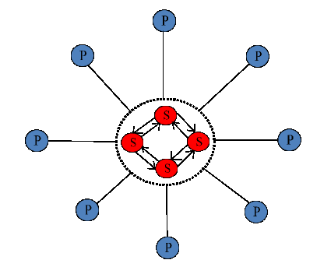

Any data request made by the clients reaches one of the servers. If the server has the data, it satisfies the request. If it doesn’t, the request is sent along the ring until it reaches the server that does have the data. If it reaches back the same server that forwarded the data, the data requested is not present in the servers. If the requests are for inserting data, the inserts are done in the server with a hash table less than or equal to those of all the other servers in the network. This takes care of load balancing in the network.

**Experimental Results and Explanations**

Jing has been responsible for coding the logic of the interactions between all the machines involved in the system. I have mostly worked on creating the code for the table hash tables present in each server. The code has been commented at appropriate places.